Lab 5

P1: Write a program to transfer the given string from source to destination using string instruction and also display the destination string.

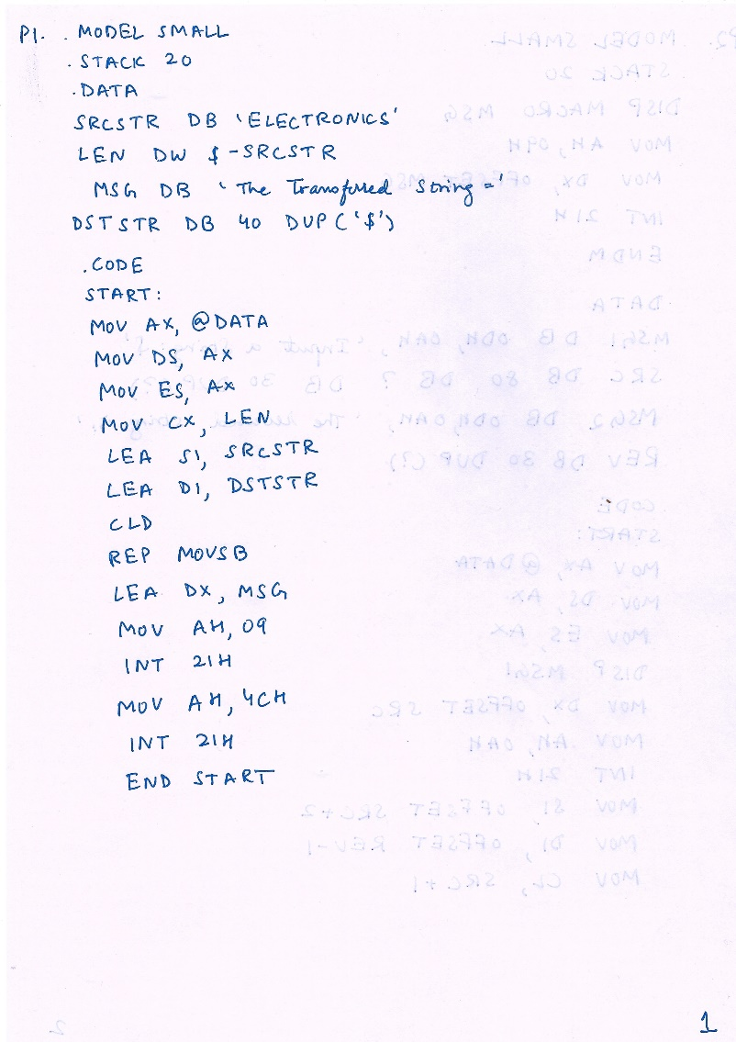

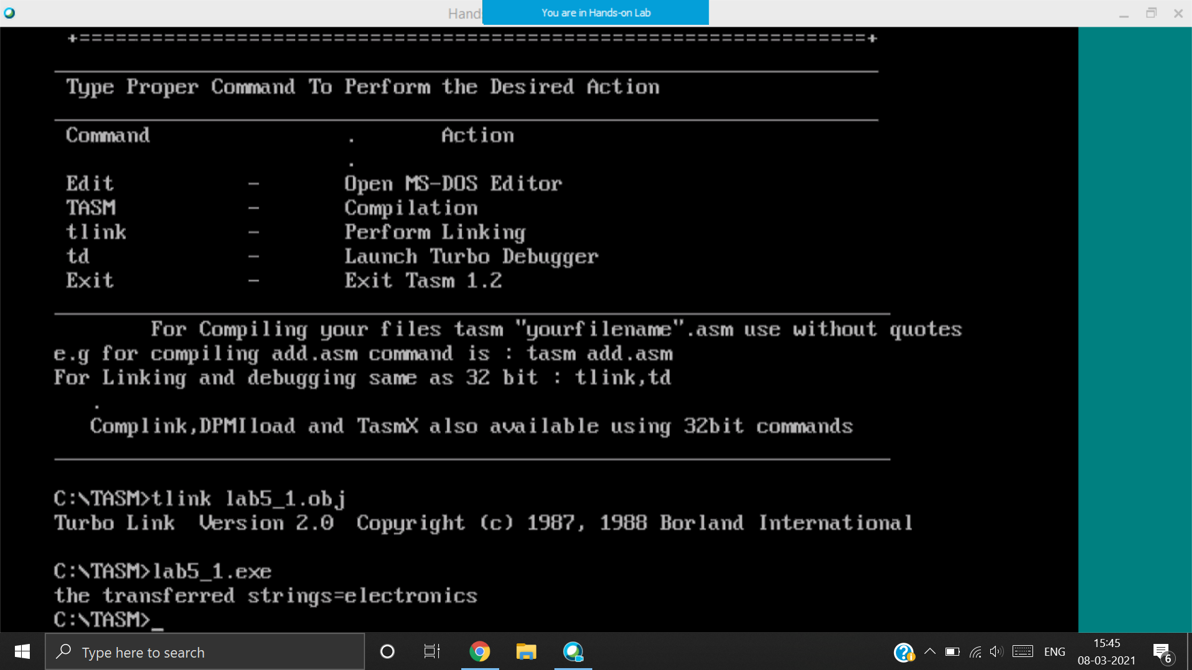

“Electronics” is transferred from SRCSTR to DSTSTR

P2: Write a program to read a string using DOS interrupts, reverse the entered string and display the same on the screen. Use MACRO for display.

|  |  |
| --- | --- |
|  |  |

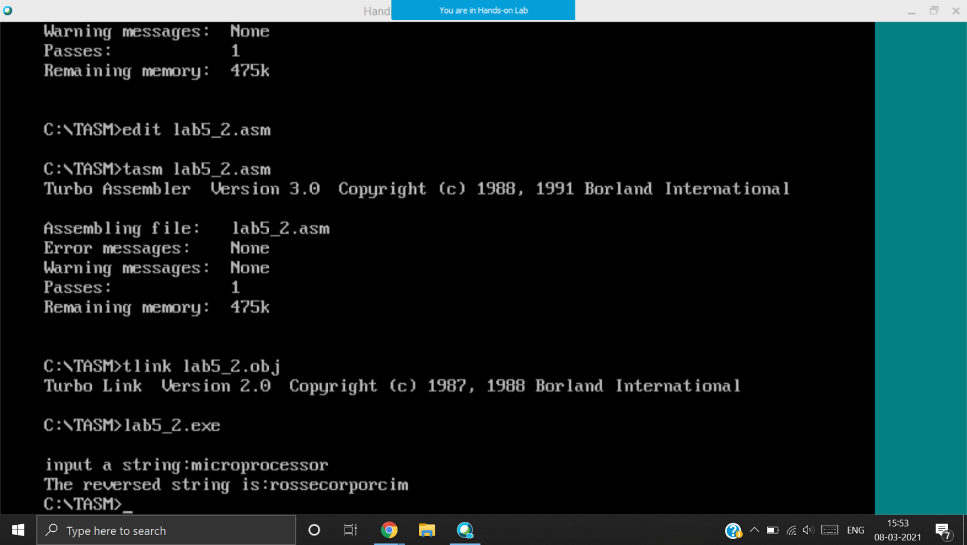

Entered string: microprocessor

Reversed string: rossecorporcim

P3: Write a program to read two digit decimal number using keyboard and search whether the number is present in an array or not. Display suitable message.

|  |  |
| --- | --- |
|  |  |
|  |  |
|  |  |
| 90H is present, hence prints “The number is present” | 18H is present, hence prints “The number is not present” |

P4: Write a program to count the number of occurrences of the letter “A” or “a” in the given message, and also count the number of words. Read the message using DOS interrupts.

|  |  |
| --- | --- |
|  |  |

